Virtual Computer Mouse using mmWave Radar (TI)

Oscar Chavez Araiza

Greyson Heath

Daniel Lu

Zane Meikle

**Midterm Report**

**Table of Contents**

Concept of Operations3

Functional System Requirements17

Interface Control Document34

Schedule and Validation46

Virtual Computer Mouse using mmWave Radar (TI)

Oscar Chavez Araiza

Greyson Heath

Daniel Lu

Zane Meikle

**Concept of Operations**

REVISION – 1.0

22 September 2024

Concept of Operations

for

Virtual Computer Mouse using mmWave Radar (TI)

Team <71>

Approved by:

_____________________________

Project Leader Date

_____________________________

Prof. Kalafatis Date

_____________________________

T/A Date

**Change Record**

| **Rev.** | **Date** | **Originator** | **Approvals** | **Description** |
| --- | --- | --- | --- | --- |
| **-** | 9/14/2024 | Zane Meikle |  | Draft Release |
| **1.0** | 9/22/2024 | Zane Meikle |  | Revision 1.0 |

**Table of Contents**

**Table of Contents** **6**

**List of Tables** **7**

**List of Figures** **8**

**1.** **Executive Summary 9**

**2.** **Introduction** **10**

2.1. Background 10

2.2. Overview 10

2.3. Referenced Documents and Standards 10

**3.** **Operating Concept** **11**

3.1. Scope 11

3.2. Operational Description and Constraints 11

3.3. System Description 12

3.4. Modes of Operations 13

3.5. Users 14

3.6. Support 14

**4.** **Scenario(s)** **15**

4.1. Presentation 15

4.2. Medical 15

**5.** **Analysis** **16**

5.1. Summary of Proposed Improvements 16

5.2. Disadvantages and Limitations 16

5.3. Alternatives 16

5.4. Impact 16

**List of Tables**

No table of figures entries found.

**List of Figures**

Figure 1: Functional System Diagram10

Figure 2: Prediction state and measurement state11

# 

# 

# Executive Summary

This project aims to create a virtual mouse using Texas Instrument’s (TI) mmWave radar. Using the mmWave radar, the system will track the user's hand and convert those movements into mouse movements on the computer. Additionally, it will recognize different gestures and convert those into mouse actions. This solution stands out based on its lower power and processing requirements, and a variety of environments in which it can easily operate.

# 

# Introduction

This project aims to make effective use of TI’s mmWave radar technology to eliminate the need for a mouse by tracking the user’s hand movements. A virtual mouse would improve a multitude of computing tasks, as opposed to using a mouse, in ways such as the following: enhanced multitasking, improved accessibility leading to a ‘hands-free’ interaction, increased ergonomics, and hygiene management. The performance of the virtual mouse will not be impacted by variations in ambient brightness or pollutant levels, as the signals can transmit usable data regardless of the environmental conditions.

## Background

Common virtual mouse systems used today rely on technology referred to as computer vision. Computer vision uses machine learning and neural networks to extract important data from video or digital images, and further analyze and compute tasks. A crucial component of the success of these systems involves the storage of countless videos and images. The system will continuously run analyses and train itself using the stored data, to the point where it can distinguish minute differences and learn to recognize patterns. Massive databases store heavy amounts of data used to execute computer vision, which requires vast resources and a significant amount of computing power.

The virtual mouse using TI’s mmWave radar technology aims to replicate the same successful results seen using computer vision, but meanwhile address and correct various technical and privacy issues. The mmWave radar does not rely on the following for meaningful data: visual data extracted from videos or photos, sufficient ambient lighting conditions, and high air transparency. The mmWave radar will consume much less power as compared to a traditional camera, and enable an even lower-latency detection and tracking of gestures. Eliminating the need for a camera resolves the growing privacy concern regarding potentially sensitive user data.

## Overview

The mmWave radar uses short wavelength electromagnetic waves, detecting the gestures in this project. The data from the radar will be communicated as frames. A gesture-detecting Machine Learning model will process the data to detect hand gestures. Detected gestures corresponding to assigned commands will have a gesture ID which will later be used to map the gesture to the mouse input. Another algorithm will track the hand and map its movements to mouse movements. A radar system can determine the range, velocity, and angle of the objects, with two electromagnetic waves transmitting and reflecting signals. Our radar system is operating at 57-64 GHz with error in a fraction of a millimeter. When the data processing unit receives the reflected signals, signals will be transferred to data plots. The computer will recognize the data plots, and convert plots to mouse commands.

## Referenced Documents and Standards

* 60GHz mmWave Sensor EVMs User’s Guide
* IWR6843, IWR6443 Single-Chip 60- to 64-GHz mmWave Sensor datasheet
* DCA1000EVM Data Capture Card User’s Guide
* Texas Instruments mmWave Radar Academy
* IEEE Xplore: An FCNN-Based Super-Resolution Mmwave Radar Framework for Contactless Musical Instrument Interface

# Operating Concept

## Scope

The virtual mouse using mmWave Radar is a proof of concept that will simulate the functionality of a simple computer mouse. A virtual mouse has been implemented using computer vision, thus this project will test the effectiveness of radar in tasks already done using computer vision. The virtual mouse will be able to control the cursor’s position, right-click, and left-click.

## Operational Description and Constraints

**3.2.1 Operational Description**  
To operate the virtual mouse, the user will connect TI’s mmWave radar and data-processing circuit boards, referred to as the mmWave radar package, to the computer. The mmWave radar package will be recognized as an I/O device and will be continuously monitoring for gestures to interact with the computer mouse. The user should ensure that the mmWave radar package is properly oriented so that it is able to detect and capture hand gestures. Additionally, the computer program that interacts and interprets the radar output should be executed and running prior to using the mmWave radar package.

**3.2.2 Constraints**Correct mouse functionality is expected when the user's hands are within a range of ten meters from the mmWave radar package, and only one hand is facing the radar. The algorithm will not recognize small hand movements as inputs.

## System Description

The mmWave Radar mouse is divided into 4 different subsystems: Chirp Optimization and Data Collection, Mouse Positioning, Gesture Recognition, and Input Mapping to the Computer.



**Figure 1**: Functional System Diagram

**Chirp Optimization and Data Collection**The Chirp Optimization and Data Collection subsystem is responsible for establishing a sufficient chirp signal and outputting useful data to be used for processing. A chirp signal is a pulsed signal that increases frequency over time, and further allows for an accurate range resolution and target detection to be observed. Heavy trial-based experiments and research will be conducted to yield an accurate target resolution for gestures using the chirp signal and will be continuously modified as needed. Following the optimization of the chirp signal, the output data will be collected and transmitted to the computer in a meaningful format for further processing.

**Mouse Positioning**The Mouse Positioning subsystem is responsible for calculating a 2D unit vector in the direction of movement of the hand. By creating a group tracker module, which utilizes clustering and gesture recognition in order to identify and monitor the existence of objects in an environment, a 2D position plot of the point cloud will be created. The gesture recognition unit will detect the viewing and remove the return signal data from the surrounding environment.

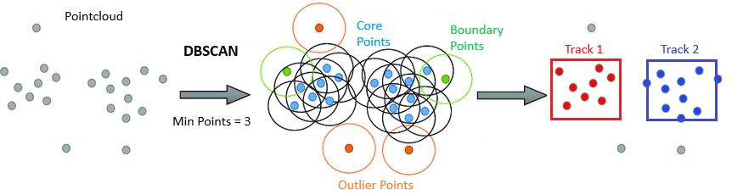

**Figure 2**: Prediction state and measurement state

**Gesture Recognition**The Gesture Recognition subsystem is responsible for producing a gesture ID representing a right click or a left click. This subsystem will use a Machine Learning(ML) model to identify a hand and discern between two gestures, left and right click. The AI model will be sensitive enough to have less than 10% chance of false positives occurring. The Machine Learning Algorithm used is CNN. The Convolutional Neural Network has been used for the Computer Vision implementation, which will make the output of the mmWave Radar implementation more predictable.

**Input Mapping to Computer**The Input Mapping to Computer subsection is responsible for taking the vector from the Mouse positioning subsection and converting that to corresponding mouse movements on the computer. As well as taking the gestures recognized by the Gesture Recognition and converting those to mouse actions on the computer.

## Modes of Operations

**Active**

The mouse is in active mode when a hand is recognized by the Gesture Recognition system. When the mouse is in active mode it will operate normally with full functionality.

**Idle**

The mouse is in idle mode when no hand is recognized. In this mode, the mouse is on standby and will produce no mouse input. Once a hand is recognized, there will be a second of delay to allow for a comfortable positioning of the hand. The mouse will then enter the active mode.

## Users

The targeted users of the mmWave Radar mouse are people who prefer to have a hands free option to controlling their computer. Basic computer literacy is all that is required to operate the mouse. The mouse will contain a manual for operation, and the gestures will reflect actions done in a physical mouse.

## Support

To help the customers install and use the radar mouse, two instruction manuals will include standard gestures and provide information on installation and self-optimization settings.

# Scenario(s)

## Presentation

The virtual computer mouse will be an excellent resource when presenting. Navigating slides with the mouse will be easy and convenient. It would be comparable to a presentation clicker/pointer in functionality.

## Medical

The hands free operation of the mouse is very useful for maintaining a clean and sterile environment in a hospital. Doctors and nurses could use the virtual mouse to control a monitor during surgery, eliminating the need for physical interaction.

# Analysis

## Summary of Proposed Improvements

* The mmWave radar package is more power efficient than a camera based virtual mouse.
* The mmWave radar package will be less processing intensive due to the computer only processing a simple point cloud format, instead of a video or photo data format.
* The mmWave radar package can successfully operate in dark and hazy environments without impacting performance.
* The mmWave radar package is hands-free making it more hygienic than a regular mouse.

## Disadvantages and Limitations

* The mmWave radar package has a lower ability to discern finer gestures due to a lower resolution when compared to a camera.
* The mmWave radar package is bigger than a conventional computer camera.
* The mmWave radar package has a low polling rate ~ 20Hz (max).
* The mmWave radar package is more expensive compared to a camera based solution.

## Alternatives

* **Virtual Mice -** Virtual mice would be a camera based solution. They would be more power and processing-intensive, and also would not function in the dark. However, they would be more accurate in determining gestures, have a smaller physical footprint, and would be significantly cheaper than our solution.
* **Physical Mouse -** A standard mouse would be far more accurate for recognizing inputs, tracking position, and running at a higher polling rate. On the other hand, it requires physical contact, making it less hygienic.
* **Touch Screens -** Physical finger inputs are able to interact directly with the screen, and would be more accurate for movement and for recognizing inputs. Nevertheless, they would be unhygienic as the user must physically touch the screen.

## Impact

This product will likely have very little impact on the environment other than the environmental impact of manufacturing it, though all devices of this type would have a similar impact. There is not likely to be any major societal impact as this will replace a device that is commonly used by society.

Virtual Computer Mouse using mmWave Radar (TI)

Oscar Chavez Araiza

Greyson Heath

Daniel Lu

Zane Meikle

**Functional System Requirements**

REVISION – 1.0

22 September 2024

Functional System Requirements

for

Virtual Computer Mouse using mmWave Radar (TI)

Team <71>

Approved by:

_____________________________

Project Leader Date

_____________________________

Prof. Kalafatis Date

_____________________________

T/A Date

**Change Record**

| **Rev.** | **Date** | **Originator** | **Approvals** | **Description** |
| --- | --- | --- | --- | --- |
| **1.0** | 9/22/2024 | Zane Meikle |  | Revision 1.0 |

**Table of Contents**

[**Table of Contents 20**](https://docs.google.com/document/d/1Dzhccj-oi1XHwTzHXd_15i8_PljE1V9L/edit#heading=h.1fob9te)

[**List of Tables 21**](https://docs.google.com/document/d/1Dzhccj-oi1XHwTzHXd_15i8_PljE1V9L/edit#heading=h.3znysh7)

[**List of Figures 22**](https://docs.google.com/document/d/1Dzhccj-oi1XHwTzHXd_15i8_PljE1V9L/edit#heading=h.2et92p0)

[**1.** **Introduction 23**](https://docs.google.com/document/d/1Dzhccj-oi1XHwTzHXd_15i8_PljE1V9L/edit#heading=h.tyjcwt)

[1.1. Purpose and Scope 23](https://docs.google.com/document/d/1Dzhccj-oi1XHwTzHXd_15i8_PljE1V9L/edit#heading=h.3dy6vkm)

[1.2. Responsibility and Change Authority 23](https://docs.google.com/document/d/1Dzhccj-oi1XHwTzHXd_15i8_PljE1V9L/edit#heading=h.4d34og8)

[**2.** **Applicable and Reference Documents**](https://docs.google.com/document/d/1Dzhccj-oi1XHwTzHXd_15i8_PljE1V9L/edit#heading=h.2s8eyo1) 24

[2.1. Applicable Documents 2](https://docs.google.com/document/d/1Dzhccj-oi1XHwTzHXd_15i8_PljE1V9L/edit#heading=h.17dp8vu)4

[2.2. Reference Documents 2](https://docs.google.com/document/d/1Dzhccj-oi1XHwTzHXd_15i8_PljE1V9L/edit#heading=h.3rdcrjn)4

[2.3. Order of Precedence](https://docs.google.com/document/d/1Dzhccj-oi1XHwTzHXd_15i8_PljE1V9L/edit#heading=h.26in1rg) 24

[**3.** **Requirements 25**](https://docs.google.com/document/d/1Dzhccj-oi1XHwTzHXd_15i8_PljE1V9L/edit#heading=h.35nkun2)

[3.1. System Definition](https://docs.google.com/document/d/1Dzhccj-oi1XHwTzHXd_15i8_PljE1V9L/edit#heading=h.1ksv4uv) 25

[3.2. Characteristics 26](https://docs.google.com/document/d/1Dzhccj-oi1XHwTzHXd_15i8_PljE1V9L/edit#heading=h.2jxsxqh)

[3.2.1. Functional / Performance Requirements 26](https://docs.google.com/document/d/1Dzhccj-oi1XHwTzHXd_15i8_PljE1V9L/edit#heading=h.z337ya)

[3.2.2. Physical Characteristics 2](https://docs.google.com/document/d/1Dzhccj-oi1XHwTzHXd_15i8_PljE1V9L/edit#heading=h.3j2qqm3)7

[3.2.3. Electrical Characteristics 27](https://docs.google.com/document/d/1Dzhccj-oi1XHwTzHXd_15i8_PljE1V9L/edit#heading=h.1y810tw)

[3.2.4. Environmental Requirements 28](https://docs.google.com/document/d/1Dzhccj-oi1XHwTzHXd_15i8_PljE1V9L/edit#heading=h.2xcytpi)

[3.2.5. Failure Propagation 2](https://docs.google.com/document/d/1Dzhccj-oi1XHwTzHXd_15i8_PljE1V9L/edit#heading=h.3whwml4)8

[**4.** **Support Requirements 30**](https://docs.google.com/document/d/1Dzhccj-oi1XHwTzHXd_15i8_PljE1V9L/edit#heading=h.2bn6wsx)

[**Appendix A Acronyms and Abbreviations 31**](https://docs.google.com/document/d/1Dzhccj-oi1XHwTzHXd_15i8_PljE1V9L/edit#heading=h.qsh70q)

[**Appendix B Definition of Terms 32**](https://docs.google.com/document/d/1Dzhccj-oi1XHwTzHXd_15i8_PljE1V9L/edit#heading=h.1pxezwc)

[**Appendix C Interface Control Documents 33**](https://docs.google.com/document/d/1Dzhccj-oi1XHwTzHXd_15i8_PljE1V9L/edit#heading=h.2p2csry)

**List of Tables**

Table 1: Subsystem Responsibility24

Table 2: Applicable Documents24

**List of Figures**

Figure 1: Concept Image23

Figure 2: System Block Diagram25

# 

# 

# Introduction

## Purpose and Scope

Operating a computer with a virtual mouse has the potential to improve a variety of computing tasks. Rather than using a camera with computer vision to enable gesture recognition, our goal is to utilize Texas Instruments’ mmWave Radar Package to build upon and improve flaws associated with computer vision.

Users will be able to directly interact with their computer using their hand as a virtual mouse. With our system, a mmWave Radar Package will actively interpret user gestures and appropriately translate them to a meaningful format for the computer to use. Machine learning algorithms will be incorporated to ensure accurate signals are detected, and to further reduce external noise. Our system shall be able to control a cursor, right-click, and left-click. In addition, our system should be able to alt+rightarrow and alt+leftarrow.

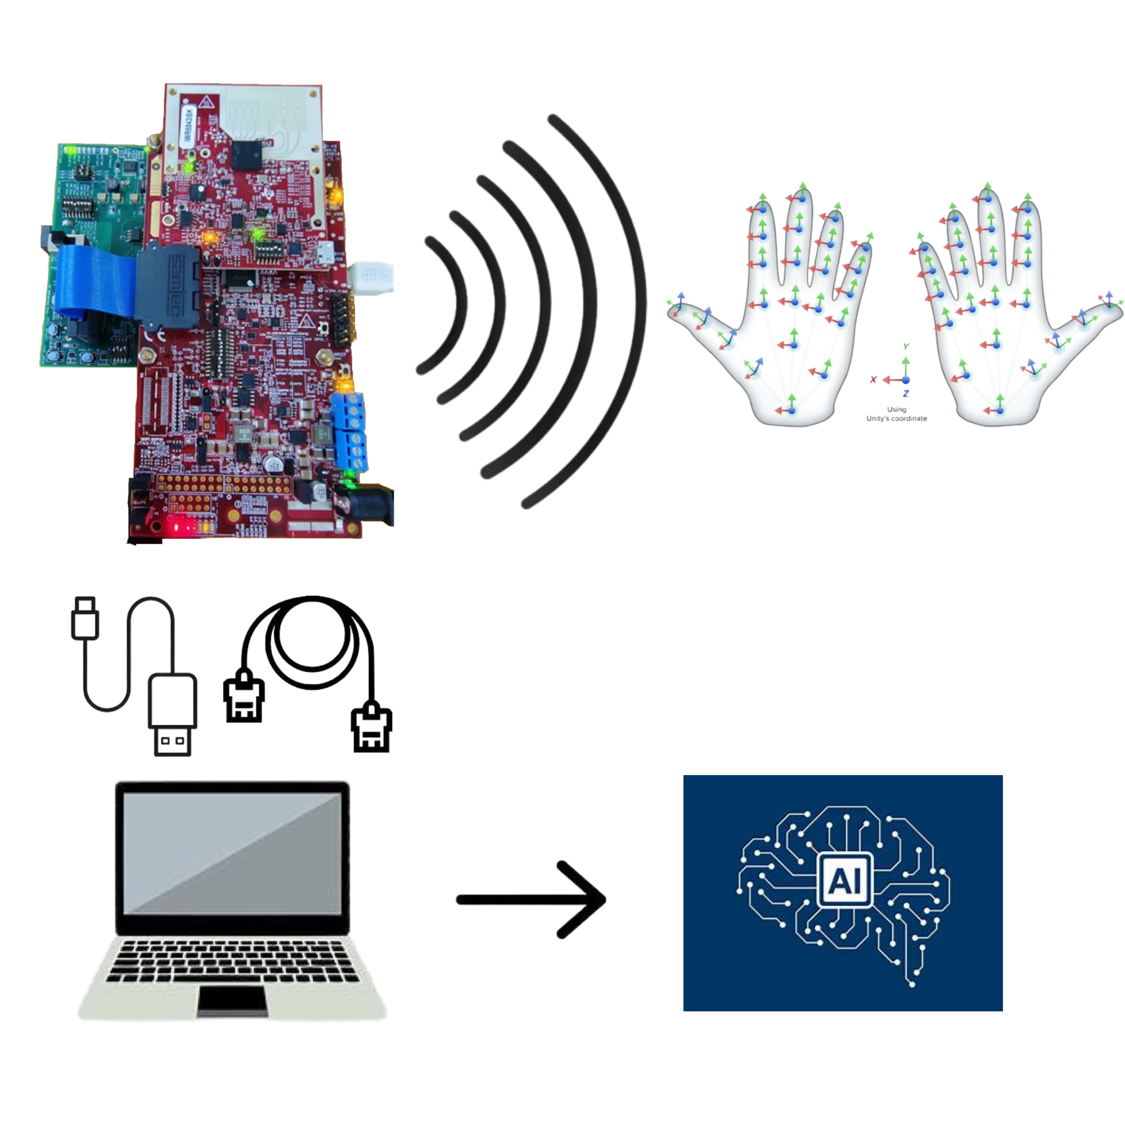

**Figure 1**: Concept Image

## Responsibility and Change Authority

The team leader, Zane Meikle, will be responsible for verifying that all project requirements are met. If these requirements are to be altered, only the team leader, Professor John Lusher, and TI can approve said changes.

| **Subsystem** | **Responsibility** |
| --- | --- |
| Chirp Optimization and Data Collection | Greyson Heath |
| Mouse Positioning | Daniel Lu |
| Gesture Recognition | Oscar Chavez Araiza |
| Input Mapping to Computer | Zane Meikle |

*Table 1: Subsystem Responsibility*

# Applicable and Reference Documents

## Applicable Documents

| **Document Number** | **Revision/Release Date** | **Document Title** |
| --- | --- | --- |
| SPRUIJ4A | Revision A - May 2018 | DCA1000EVM Data Capture Card User’s Guide |
| SWRU546E | Revision E - November 2020 | 60GHz mmWave Sensor EVMs |

*Table 2: Applicable Documents*

## Reference Documents

Due to all documents being immediately applicable to the virtual mouse mmWave Radar Package system, there are no referenced documents as of now.

## Order of Precedence

In the event of a conflict between the text of this specification and an applicable document cited herein, the text of this specification takes precedence without any exceptions.

All specifications, standards, exhibits, drawings, or other documents that are invoked as “applicable” in this specification are incorporated as cited. All documents that are referred to within an applicable report are considered to be for guidance and information only, except ICDs that have their relevant documents considered to be incorporated as cited.

# 

# Requirements

## System Definition

The virtual mouse mmWave Radar Package is a reliable way to operate a computer without physically interacting with a traditional computer mouse. It enables users to actively use gestures to simulate the use of a computer mouse. The virtual mouse mmWave Radar Package consists of four subsystems: Chirp Optimization and Data Collection, Mouse Positioning, Gesture Recognition, and System to Mouse Input Mapping.

The mmWave Radar module will collect data as a frame which will be transmitted to the computer via ethernet. The data will then be analyzed by an ML algorithm to determine if a hand/hand gesture was detected. Another algorithm will track the hand to produce a location for the mouse pointer. The gesture ID produced by the ML algorithm and the position vector will be passed to another program which will produce the mouse inputs.



**Figure 2:** Block Diagram of System

Using computer USB and ethernet ports, and a standard 120V outlet, the mmWave Radar Package will be connected to and partially powered by both the user's computer and a power brick attached to a standard 120V outlet. Software development kits from Texas Instruments will be used to communicate and properly configure the mmWave Radar Package boards, and ultimately interpret the data seen from the radar via the computer USB and ethernet ports. The data will be used by an ML program to identify hand gestures used to represent right and left clicks. Once a hand gesture is recognized the program will output a gesture ID which will be passed to the mapping program.

Mouse positioning is converted from the data of radar signals. With the application of the gesture recognition system and the SDK from Texas Instruments, position, velocity, and acceleration of the gesture will be plotted as a 3D graph. All the position vectors will be sent to the Input Mapping Program. The gestures and positioning vectors from the ML program and Mouse Positioning Program will then go to the Input Mapping Program where they will be translated into actual mouse movements and actions.

## Characteristics

### Functional / Performance Requirements

#### **False Positive**

The maximum number of non-gestures triggering a mouse input shall be less than 10%

*Rationale: The system’s gesture recognition depends on an AI model, thus mischaracterization by the AI is inevitable.*

#### **Recognition of Position**

The position data in the point cloud form, corresponding to thousands of data points, is converted from radar signals. With the application of the gesture recognition system, multiple points(5-10) instead of a point-cloud will be used to represent a gesture. The error of the point-cloud corresponding to the hand must be less than 1%.

*Rationale: The recognition and positioning system must detect the right gesture and position from hundreds of example tests with accuracy close to 100%.*

#### **Angle of Detection**

The mmWave Radar Package should be able to detect within a range of 80 degrees from where it is positioned.

*Rationale: The user will be free to control the virtual mouse within a range of angles, meaning the user does not have to be directly in front of the antenna.*

* + - 1. **Distance of Detection**

The mmWave Radar Package should be able to detect within a range of 1-ft to 15-ft from where it is positioned.

*Rationale: The user will use the mouse when not near the radar, so the mouse should accommodate a range of distances where the mouse is guaranteed to work.*

* + - 1. **Correct Hand Positioning**

The mmWave Radar Package should only recognize gestures when the hand is up-right.

*Rationale: The user should be comfortable with the hand positioning, thus limiting the positions in which the gestures are recognized will minimize incorrect usage of the mouse.*

### Physical Characteristics

#### **System Area**

The system can operate over any area up to 15 feet so long as the mmWave Radar Package is within direct line of sight of the user’s gestures.

*Rationale: As long as the antennas are oriented towards the user and their gestures, and the mmWave Radar Package remains flat on its surface, the assembled package will have no area restriction.*

#### **Volume Envelope**

The volume envelope of the assembled mmWave Radar Package excluding the power, ethernet, and microUSB cables shall not exceed a height of 2 inches, a width of 4 ½ inches, and a length of 8 inches.

*Rationale: The assembled boards will lie upon one another, and will not occupy a large amount of space.*

#### **Assemble Location**

The assemble location information for the virtual mouse mmWave Radar Package system shall be captured in the Search and Rescue System ICD.

*Rationale: As the assembled mmWave Radar Package will lie upon the user’s desk, the mounted location requires a specified orientation such that the antenna is facing towards the user and their gestures.*

### Electrical Characteristics

#### **Inputs**

1. The presence or absence of any combination of the input signals in accordance with ICD specifications applied in any sequence shall not damage the user’s computer nor the mmWave Radar Package, reduce its life expectancy, or cause any malfunction, either when the unit is powered or when it is not.
2. No sequence of command shall damage the user’s computer nor the mmWave Radar Package, reduce its life expectancy, or cause any malfunction.

*Rationale: By design, should limit the chance of damage or malfunction by user/technician error.*

##### Power Consumption

The maximum peak power of the system shall not exceed 15 watts.

*Rationale: This is a requirement that ensures proper and continuous operation of the mmWave Radar Package.*

##### Input Voltage Level

The input voltage level for the virtual mouse mmWave Radar Package System shall be 5V.

*Rationale: The mmWave Radar Package is designed to operate off of a 5V 2.5A barrel power brick, and a standard 5V USB connection to the user’s computer.*

##### External Commands

The virtual mouse mmWave Radar Package System shall document all external commands in the appropriate ICD.

*Rationale: The ICD will capture all interface details from the low level electrical to the high-level packet format.*

#### **Outputs**

##### Data Output

The system shall use the input data from radar to do target tracking. The tracker will output the data such as 3D position, velocity, and acceleration, where the user can check when they use the virtual mouse on the computer.

*Rationale: Being able to see active data output will allow the user to ensure the mmWave Radar Package is properly connected to the computer and functioning.*

### Environmental Requirements

The mmWave Radar Package shall be designed to withstand and operate in the environments and laboratory tests specified in the following section.

*Rationale: The mmWave Radar Package may be placed in a variety of environments, thus the requirements listed below describe the limitations*

#### **Thermal**

The virtual mouse mmWave Radar Package shall be able to function properly in an environment with temperatures ranging from -4°F to 140°F.

*Rationale: This is a requirement specified by Texas Instruments’ for proper functioning of the circuit boards.*

#### **Rain**

The mmWave Radar Package shall be distanced from the water.

#### **Ambient Brightness**

The mmWave Radar Package shall be able to operate in any environment regardless of ambient brightness.

*Rationale: Due to the method of collecting data using electromagnetic fields, ambient brightness will not impact the resolution of the radar.*

### Failure Propagation

All errors in the subsystems will be passed through to the Input Mapping Program’s terminal where the program is running. If there is not output from a subsystem or if the subsystem is not responding then whichever subsystem detects the

#### **Gesture Recognition Program and Mouse Positioning Program**

If these subsystems are unable to connect or receive data from the mmWave Radar Package, then they are to send an error code to the Input Mapping Program.

#### **Input Mapping Program**

If this program receives an error code from the other programs or is unable to connect to the Gesture Recognition Program or Mouse Positioning Program then it will end the program displaying the corresponding error in the terminal.

# Support Requirements

The mmWave Radar Package requires a computer using Windows 10 or later. Users must provide two power sources to the mmWave Radar Package, those being through a computer USB port and a 5V 2.5A barrel power brick plugged into a standard 120V outlet. Associated software that enables the functionality of the device will be required to communicate with the mmWave Radar Package.

# Appendix A: Acronyms and Abbreviations

3D Three Dimensional

AI Artificial Intelligence

BIT Built-In Test

CCA Circuit Card Assembly

EMC Electromagnetic Compatibility

EMI Electromagnetic Interference

EO/IR Electro-optical Infrared

FOR Field of Regard

FOV Field of View

FSR Functional System Requirements

GPS Global Positioning System

GUI Graphical User Interface

Hz Hertz

ICD Interface Control Document

ID Identification

kHz Kilohertz (1,000 Hz)

LCD Liquid Crystal Display

LED Light-emitting Diode

mA Milliamp

mmWave Millimeter Wave

MHz Megahertz (1,000,000 Hz)

ML Machine Learning

MTBF Mean Time Between Failure

MTTR Mean Time To Repair

mW Milliwatt

PCB Printed Circuit Board

RF Radar Frequency

RMS Root Mean Square

SDK Software Development Kit

TBD To Be Determined

TI Texas Instruments

TTL Transistor-Transistor Logic

USB Universal Serial Bus

VME VERSA-Module Europe

# Appendix B: Definition of Terms

# Appendix C: Interface Control Documents

Virtual Computer Mouse using mmWave Radar (TI)

Oscar Chavez Araiza

Greyson Heath

Daniel Lu

Zane Meikle

**Interface Control Document**

REVISION – 1.0

22 September 2024

Interface Control Document

for

Virtual Computer Mouse using mmWave Radar (TI)

Team <71>

Approved by:

_____________________________

Project Leader Date

_____________________________

Prof. Kalafatis Date

_____________________________

T/A Date

**Change Record**

| **Rev.** | **Date** | **Originator** | **Approvals** | **Description** |
| --- | --- | --- | --- | --- |
| **1.0** | 9/22/2024 | Zane Meikle |  | Revision 1.0 |

**Table of Contents**

**Table of Contents 37**

**List of Tables 38**

**List of Figures 39**

**1.** **Overview 40**

**2.** **References and Definitions 41**

2.1. References 41

2.2. Definitions 41

**3.** **Physical Interface 42**

3.1. Weight 42

3.2. Dimensions 42

3.3. Assembly Location 42

**4.** **Thermal Interface 43**

**5.** **Electrical Interface 44**

5.1. Input Power 44

5.2. Voltage and Current Levels 44

**6.** **Communications / Device Interface Protocols 45**

6.1. Host Device 45

**List of Tables**

Table 1: mmWave Radar Package Weight42

Table 2: mmWave Radar Package Dimensions42

Table 3: Assembled mmWave Radar Package Dimensions42

Table 4: Maximum Voltage and Current Levels46

Table 5: Expected Average Voltage and Current Levels46

**List of Figures**

No table of figures entries found.

# 

# 

# 

# Overview

The Interface Control Document will provide users with information about the operating status of the product in different environments, such as thermal, physical, and electrical conditions.

# 

# References and Definitions

## References

Refer to section 2.2 of the Functional System Requirements document.

## Definitions

A Amp

TBD To Be Determined

USB Universal Serial Bus

W Watt

V Volt

# 

# Physical Interface

## Weight

Dimensions are in inches.

**3.1.1. mmWave Radar Package**

| **Component** | **Weight** | **Number of Items** | **Total Weight** |
| --- | --- | --- | --- |
| DCA1000EVM | TBD | 1 | TBD |
| MMWAVEICBOOST | TBD | 1 | TBD |
| IWR6843AOPEVM | TBD | 1 | TBD |

*Table 1: mmWave Radar Package Weight*

## Dimensions

Dimensions are in inches.

**3.2.1. mmWave Radar Package**

| **Component** | **Length** | **Width** | **Height** |
| --- | --- | --- | --- |
| DCA1000EVM | 4.40 | 3.55 | 0.67 |
| MMWAVEICBOOST | 5.33 | 2.80 | 0.40 |
| IWR6843AOPEVM | 4.75 | 1.22 | 0.18 |

*Table 2: mmWave Radar Package Dimensions*

**3.2.1. Assembled mmWave Radar Package**

| **Component** | **Length** | **Width** | **Height** |
| --- | --- | --- | --- |
| Assembled mmWave Radar Package | 7.90 | 4.40 | 2.00 |

*Table 3: Assembled mmWave Radar Package Dimensions*

## Assemble Location

The virtual mouse mmWave Radar Package will be assembled and placed nearby the user’s computer. The assembled mmWave Radar Package will need to be oriented such that the antenna on the IWR6843AOPEVM module is facing towards the area the user will be located. This will ensure that the accurate capturing of gestures is performed.

# Thermal Interface

The mmWave Radar Package contains a heat sink for the radar module, that being the IWR6843AOPEVM. Due to the consistent output and active monitoring for the radar signals, the heat sink will keep the module from overheating and prevent decreased efficiency. This is the only thermal interface for the mmWave Radar Package, as all other components are capable of dissipating their own heat.

# 

# Electrical Interface

## Input Power

### mmWave Radar Package

The mmWave Radar Package will receive power from a 2.1mm 5V at 2.5A Barrel Jack and will also receive power from a micro USB port that will deliver 5 V at 0.5 A. User’s will have to provide their own power to their computer.

## Voltage and Current Levels

### Maximum Values

| Component | Voltage (V) | Current (A) | Power (W) |
| --- | --- | --- | --- |
| mmWave Radar Package | 5 | 3 | 15 |

*Table 4: Maximum Voltage and Current Levels*

These values are based on the specifications provided by Texas Instruments.

### Expected Average Values

| Component | Voltage (V) | Current (A) | Power (W) |
| --- | --- | --- | --- |
| mmWave Radar Package | 5 | TBD | TBD |

*Table 5: Expected Average Voltage and Current Levels*

The Power and Current cannot be determined until the system is finished and we know what load the mmWave radar package will be under.

# Communications / Device Interface Protocols

## Host Device

The host device and the mmWave radar package via USB 2.0 micro usb cable and a RJ45 Ethernet cable.

Virtual Computer Mouse using mmWave Radar (TI)

Oscar Chavez Araiza

Greyson Heath

Daniel Lu

Zane Meikle

**Schedule and Validation**

REVISION – 1.0

22 September 2024

**List of Tables**

Table 1: Schedule49

Table 2: Validation Plan51

**List of Figures**

Figure 1: Gantt Chart50

# 

Schedule:

| Work | End Date | Owner | Status | Date Completed |
| --- | --- | --- | --- | --- |
| Concept of Operations | 9/15/2024 | All | Complete | 9/14/2024 |
| Functions System Requirements | 9/26/2024 | All |  |  |
| Interface Control Document | 9/26/2024 | All |  |  |
| Midterm Presentation | 9/25/2024 | All |  |  |
| Radar Out-of-box Demo (mmWave and 6843) | 9/30/2024 | Greyson |  |  |
| Gesture Resolution R&D (Chirp Optimization) | 10/12/2024 | Greyson |  |  |
| Input Mapping Intro Project | 10/14/2024 | Zane |  |  |
| Machine Learning Intro Project | 10/14/2024 | Oscar |  |  |
| Chirp Optimization Intro Project | 10/14/2024 | Greyson |  |  |
| Data Processing Intro Project | 10/14/2024 | Daniel |  |  |
| Find a fitting ML model to use a base for our ML model | 10/14/2024 | Oscar |  |  |
| Output Real-time Data using DCA1000EVM | 10/16/2024 | Greyson |  |  |
| Create a dataset to train/test/validate the ML model | 10/18/2024 | ALL |  |  |
| Mouse Positioning Research | 10/20/2024 | Daniel |  |  |
| Input Mapping get initial code (mouse movement and actions) working | 10/20/2024 | Zane |  |  |
| Train tracking model | 10/21/2024 | Daniel |  |  |
| Train ML Model | 10/21/2024 | Oscar |  |  |
| Status Update Slides | 10/22/2024 | All |  |  |
| Status Update Presentation | 10/23/2024 | All |  |  |
| Make test code for Input Mapping Subsystem | 11/01/2024 | Zane |  |  |
| Test/Validate ML model | 11/01/2024 | Oscar |  |  |
| Refine and stress-test Chirp Optimization | 11/01/2024 | Greyson |  |  |
| Validate code and make a configurable tuning system to ensure proper scaling | 11/14/2024 | Zane |  |  |
| Test the hand position tracker | 11/14/2024 | Daniel |  |  |
| Make Final Presentation | 11/19/2024 | All |  |  |
| Final Presentation | 11/20/2024 | All |  |  |
| Make sure all subsystems are ready for Final Demo | 11/25/2024 | All |  |  |
| Final Demo | 11/26/2024 | All |  |  |
| Make Final Report | 12/5/2024 | All |  |  |
| Final Report | 12/5/2024 | All |  |  |

**Table 1**: Schedule

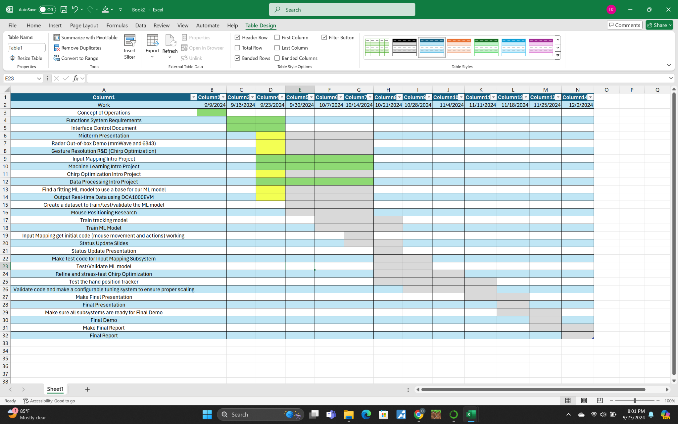**Figure 1**: Gantt Chart

Validation Plan:

| Task | Specification | Result | Owner |
| --- | --- | --- | --- |
| Mouse Movement | Mouse can be moved to all corners of the screen by the program. |  | Zane |
| Mouse Actions | The program must be able to right click and left click. |  | Zane |
| Hand Plots | The shape of the gesture should be represented correctly by the plots. |  | Daniel |
| Hands Positions | The position of the hand must be correct according to the axis of radar |  | Daniel |
| Hand Recognition | ML model can recognize the dominant hand. |  | Oscar |
| Gesture Recognition | ML model can correctly identify and categorize hand gestures at least 90% of the time. |  | Oscar |
| Functional Radar System | The DCA1000EVM, IWR6843AOPEVM, and MMWAVEICBOOST all properly communicate with the computer and transmit data. |  | Greyson |
| Radar Range | The radar can capture gestures from 1 to 15 feet. |  | Greyson |
| Radar Angle | The radar can capture gestures in an 80 degree range from its position. |  | Greyson |
| Hand positioning | The radar will only recognize gestures when the hand is approximately up-right |  | Oscar |

**Table 2**: Validation Plan